TRADITIONAL MEDICINE

Introduction:
Traditional Indian medicine is one of the oldest medical sciences in the world. Ayurveda, the most widely used system in traditional Indian medicine, emphasizes holistic medicine, which takes the body, mind, and spirit as a whole. It is based on the principle that human beings achieve physical, mental, and emotional health through harmonious coexistence with nature.
The basic theories of Indian medicine are the five elements theory and the three humoralisms theory. The five elements theory is a natural philosophy in Vedic culture that is used in medicine to explain human physiology. The five elements theory holds that everything in the world is composed of five basic elements—Prithvi (earth), Jala (water), Agni (fire), Vayu (air), and Akasha (ether)—that supplement the corresponding elements in the human body after being ingested. According to the three humoralisms theory, there are three kinds of humoralisms—(Tridosha) gas (Vata), bile (Pitta), and mucus (Kapha)—the balance of which determines the health and disease status of the human body. Disease is caused by internal and external factors leading to an imbalance of the three humoralisms, and the treatment is to restore their balance by means of medicine and diet therapy.^{2,3} Later, seven kinds of tissues (Saptadhatus) (Rasa, Rakta, Mamsa, Meda, Asthi, Majja, and Shukra—that is, chyle, blood, flesh, fat, bone, marrow, and sperm/ovum) were added, all of which were thought to be derived from food. Others incorporated malas: Purisha, Mutra, and Sweda (i.e., feces, urine, and sweat). In this way, a relatively complete theoretical system has been formed, holding that disorders of humoralism, body composition, and excreta are the sources of disease.

As an organism, the tissues of the human body are formed by the combination and transformation of these five basic elements. Both internal and external factors can disrupt the balance of nature and lead to disease. Imbalances can be caused by overeating, bad habits, and ignoring rules for healthy living. At the same time, abnormal seasons, incorrect exercise, improper use of sensory organs, and adverse effects of body and mind will also disrupt the existing normal balance. The basic treatment methods can be summed up as “body cleansing” and “mind cleansing.” By adjusting the diet, the body and mind system can be restored to balance, and bad habits and behaviors can be corrected; or, disorders of the body can be regulated by drugs.
History of Traditional Indian Medicine:
As early as 2500 BC, there was an early civilization in the Indus River Basin (i.e., the Halaba culture), with cities, and well-developed handicrafts, such as textile, pottery, and metal processing. During the Vedic era (about 1400 BC to 600 BC), the Aryans who dominated India created a Vedic culture with Brahmanism as the core and also inspired the initial formation of ancient Indian philosophy and natural philosophy. There are four major collections of documents describing various kinds of knowledge, thoughts, and legends in the Vedic era, i.e., the Rigveda, Samaveda, Yajurveda, and Atharvaveda. Among them, the Atharvaveda already contains many medical contents, including information on human structure, physiology, embryos, disease, medicine, and treatment. However, the medicine in this period was not based on the basic theory of naturalism but on a kind of witch doctor.

From about 1500 BC to 1000 BC, Ayurvedic medicine, as one of the four Upavedas (supplements and deductions of Vedas), was gradually divided into two schools—the Atreya Inner Medicine School and Dhanvantari Surgery School. In the early 100 BC, scholars in these two categories wrote two major books on Ayurvedic medicine: the Caraka Samhita and the Susruta Samhita. Around AD 500, the third important Ayurveda medical work, Astanga Hridaya Samhita, was published, which integrated the views of two medical schools of Ayurveda. From AD 500 to AD 1900, a total of 16 important drug monographs were published one by one as supplements to Ayurveda’s medical classics.

There is evidence that Ayurvedic medicine has enriched almost all medical systems in the world. Through sea trade with India, Egyptians learned Ayurvedic medicine; the invasion of Alexander also brought the Greeks and Romans into contact with Ayurveda medicine. Similarly, with the spread of Buddhism to the East, Ayurvedic medicine reached the East.

AYURVEDA

Introduction:
Ayurveda is an ancient system of alternative medicine that originated in the Indian subcontinent and is widely practiced in India and Nepal, with approximately 80% of the population using Ayurvedic treatments. It is based on the concept of balancing the three doshas – Vata, Pitta, and Kapha – to maintain health and prevent disease. Ayurvedic therapies include herbal medicines, special diets, meditation, yoga, massage, and surgical techniques such as rhinoplasty and cataract surgery.
Classical Ayurvedic texts, such as the Sushruta Samhita and Charaka Samhita, date back to the first millennium BCE and attribute medical knowledge to divine sources transmitted to sages and then to physicians. While Ayurveda has evolved over two millennia and gained popularity globally, especially in the West, it is often criticized as pseudoscientific due to the inclusion of toxic metals like lead and mercury in some preparations.
Studies have identified contamination in several Ayurvedic products, raising public health concerns about heavy metal toxicity. Despite these criticisms, Ayurveda continues to be practiced widely and has been adapted for modern contexts, particularly in the 20th century through figures like Baba Hari Dass and Maharishi Mahesh Yogi.
History:
The origins of Ayurveda are traced back to ancient India, with some scholars suggesting its existence since the Indus Valley Civilization, though this remains speculative due to the undeciphered Indus script. The Atharvaveda, one of the oldest Vedic texts, contains hymns and prayers aimed at healing, indicating the early presence of medicinal practices. According to traditional accounts, Ayurveda was passed down from Brahma to Dhanvantari, the god of medicine, and subsequently to sages like Agnivesha.
Ayurveda is one of the few ancient medical systems still widely practiced today. However, its foundational concepts, developed millennia ago, are often criticized as outdated by modern medical standards. This led to a significant debate in early 20th-century India between proponents of pure Ayurveda (śuddha) and those advocating for modernized or syncretized Ayurveda (aśuddha). The debate continues today, both within India and in the global context, as Ayurveda strives to balance tradition with contemporary scientific validation.
Etymology:
The term āyurveda is composed of two words, āyus,, "life" or "longevity", and veda, , "knowledge", translated as "knowledge of longevity" or "knowledge of life and longevity".
Eight components:
Classical Ayurvedic texts describe medicine as being divided into eight components (Aṣṭāṅga Ayurveda), a concept that first appears in the ancient Sanskrit epic, the Mahābhārata (c. 4th century BCE). These components encompass various aspects of healthcare and well-being, forming the core structure of traditional Ayurvedic practice.
- Kāyachikitsā (General Medicine):
- Focuses on the treatment of physical ailments and diseases related to the body.
- Kaumāra-bhṛtya (Pediatrics):
- Covers prenatal and postnatal care, child health, methods of conception, and childhood diseases.
- Śalyatantra (Surgery):
- Involves surgical techniques, removal of foreign objects, and management of trauma.
- Śhālākyatantra (ENT and Upper Body Ailments):
- Deals with diseases of the ears, eyes, nose, mouth, and other upper body cavities.
- Bhūtavidyā (Psychiatry and Spirit Healing):
- Addresses mental health issues and conditions attributed to spirit possession or psychological disturbances.
- Agadatantra (Toxicology):
- Studies poisons from animals, plants, and minerals, as well as antidotes and treatments for poisoning.

- Rasāyantantra (Rejuvenation and Longevity):
- Emphasizes therapies and tonics that enhance longevity, vitality, and mental clarity.
- Vājīkaraṇatantra (Aphrodisiacs and Fertility):
- Focuses on enhancing reproductive health, sexual vitality, and transforming sexual energy into spiritual energy.
Principles and terminology:
Ayurveda is intricately linked with ancient Indian philosophies such as Samkhya, Vaisheshika, Buddhism, and Jainism, emphasizing a holistic approach to health that includes the body, mind, and spirit. Central to Ayurvedic thought is the belief that maintaining balance in bodily elements is crucial for preventing illness. It cautions against suppressing natural urges, as doing so is considered to disrupt the body's equilibrium and lead to disease. For instance, Ayurveda suggests that suppressing sneezing could potentially cause shoulder pain, illustrating its focus on the interconnectedness of bodily functions.
The fundamental principles of Ayurveda revolve around the concept of Tridosha, which comprises three elemental bio-energies: Vata (Air), Pitta (Fire), and Kapha (Earth and Water). These doshas govern various physiological and psychological functions in the body. Vata is associated with movement and the nervous system, Pitta with metabolism and digestion, and Kapha with structure and lubrication. Each individual is believed to have a unique constitution or prakriti, determined by the predominant doshas, influencing their physical and mental characteristics.
In addition to doshas, Ayurveda identifies seven primary tissues, known as Dhatus, which include rasa (chyle), rakta (blood), mamsa (muscle), meda (fat), asthi (bone), majja (marrow), and shukra (semen). These tissues are formed sequentially and are considered vital for overall health. The proper elimination of waste products or Malas (urine, feces, and sweat) is also emphasized, as any obstruction in their expulsion is believed to result in the accumulation of toxins and subsequent disease.
Ayurveda also recognizes five fundamental elements, known as Pancha Mahabhutas – earth, water, fire, air, and ether. These elements combine to form both the body’s physical structure and its doshas. Additionally, twenty inherent qualities or Gunas, such as heavy/light, hot/cold, and dry/unctuous, are believed to influence the state of health and disease.
The Ayurvedic concept of Ama refers to a toxic byproduct resulting from improper digestion. Ama is considered a root cause of various diseases, leading to blockages and disruptions in bodily functions. Mental health is also addressed through the doshas, with Vata associated with anxiety and nervous disorders, Pitta with anger and skin ailments, and Kapha with lethargy and respiratory conditions.

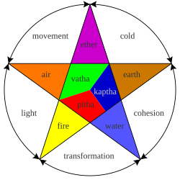
FIG: The three doshas and the five elements from which they are composed
In the Indian knowledge system, Ayurveda holds a significant position as a subsidiary Veda (Upaveda) and is sometimes referred to as the Fifth Veda, indicating its spiritual and cultural importance. The foundational principles of Ayurveda are also evident in the Atharvaveda, which includes references to medicinal plants and healing practices. Despite its ancient origins, Ayurveda remains relevant today, blending spiritual, physical, and medicinal elements to promote holistic health.
Practice:
Ayurvedic practitioners regard physical existence, mental existence, and personality as three separate elements of a whole person with each element being able to influence the others. This holistic approach used during diagnosis and healing is a fundamental aspect of ayurveda. Another part of ayurvedic treatment says that there are channels (srotas) which transport fluids, and that the channels can be opened up by massage treatment using oils and Swedana (fomentation). Unhealthy, or blocked, channels are thought to cause disease.

FIG: Physician taking pulse
Diagnosis:
Ayurveda uses the Eightfold Examination (Ashta Sthana Pariksha) to assess health through pulse, urine, stool, tongue, speech, touch, vision, and overall appearance. Practitioners rely on the five senses for diagnosis, such as using touch to assess skin texture and hearing to evaluate breathing. Additionally, Ayurveda examines marma points, vital areas on the body, to detect energy blockages and guide treatment. This holistic approach aims to identify the root cause of illness rather than just the symptoms.
Treatment and prevention:
Contemporary Ayurveda prioritizes maintaining vitality by fostering a balanced metabolism and healthy digestion, moving away from its classical emphasis on surgical practices like Śalya-cikitsā (general surgery) and Śālākya-tantra (ENT and eye surgery). The approach includes yoga, meditation, and a Sattvic diet, which promotes pure, wholesome foods that nurture the body and mind. Additionally, Ayurveda emphasizes the principle of Dinacharya, advocating for routines aligned with natural rhythms, such as regular sleep, exercise, and work patterns. Hygienic practices like bathing, oil pulling, tongue scraping, and eye washing are considered essential for cleansing and preventing disease, reflecting Ayurveda’s holistic view of health as a balance between body, mind, and environment.
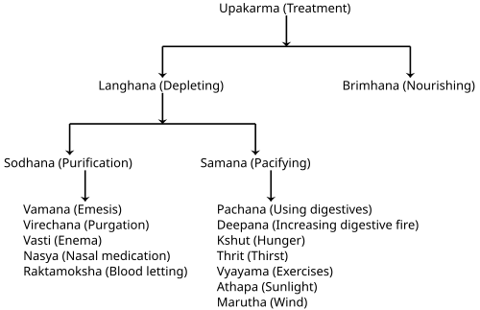
FIG: Treatment procedures
Conclusion:
Ayurveda, with its origins in ancient India, remains a comprehensive system of holistic medicine that addresses physical, mental, and spiritual well-being. Rooted in the principles of balancing the three doshas — Vata, Pitta, and Kapha, it integrates practices like herbal medicine, diet, yoga, and meditation to restore health and prevent disease. Despite modern critiques and concerns regarding certain formulations, Ayurveda continues to influence contemporary wellness practices and serves as a valuable resource for natural healing and preventive healthcare. As interest in integrative medicine grows, Ayurveda offers a time-tested framework for achieving holistic well-being.

MEDICINAL PLANTS

Introduction:
Medicinal plants, also known as medicinal herbs, have been integral to traditional medicine since ancient times. They produce a variety of chemical compounds that serve protective functions against insects, fungi, diseases, and herbivores. The earliest records of medicinal plants date back to the Sumerian civilization (c. 3000 BC), where clay tablets listed various herbal remedies, including opium. The Ebers Papyrus (c. 1550 BC) from ancient Egypt described over 850 plant-based medicines, while the Greek physician Dioscorides compiled over 600 medicinal plants in his work, De materia medica (c. 60 AD), a text that remained influential for 1500 years.
Modern drug research often draws from ethnobotanical knowledge, leading to the discovery of compounds such as aspirin, digoxin, quinine, and opium. These compounds are primarily classified into alkaloids, glycosides, polyphenols, and terpenes. Despite the widespread use of medicinal plants in folk medicine, many claims lack scientific validation, leading to criticisms of the botanical herbal market as being poorly regulated and often based on pseudoscience. Additionally, medicinal plants face significant threats, including climate change, habitat destruction, and over-collection driven by increasing market demand.
History:
The use of medicinal plants dates back to prehistoric times, with early civilizations like the Sumerians (3000 BC) and Egyptians (1550 BC) documenting plant-based remedies, including opium and over 850 herbal formulations in the Ebers Papyrus. In ancient Greece, Dioscorides’ De materia medica (60 AD) cataloged 600 plants and 1,000 recipes, influencing botanical medicine for centuries. During the Middle Ages, herbal knowledge was preserved by monastic scholars, while Traditional Chinese Medicine and Ayurveda also developed extensive herbal practices. The Renaissance spurred scientific exploration, leading to the isolation of plant compounds like aspirin, quinine, and digoxin, marking the birth of modern pharmacology. Today, medicinal plants remain essential in traditional medicine, though overharvesting and habitat loss threaten their sustainability.
Phytochemical Basis:
Plants produce chemical compounds that offer evolutionary advantages, such as defense against herbivores and parasites. Some of these compounds, known as phytochemicals, have pharmacological properties that can be harnessed for medicinal use. For example, daffodils (Narcissus) contain alkaloids like galantamine, which is approved for treating Alzheimer’s disease. These alkaloids are concentrated in plant parts prone to herbivory and can also deter parasites.
Modern efforts to understand medicinal plants have led to the development of the Medicinal Plant Transcriptomics Database, which provides genetic data for several plant species to facilitate drug research. Major classes of phytochemicals include alkaloids, glycosides, polyphenols, and terpenes, each with distinct medicinal properties.
Alkaloids:
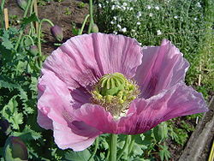
FIG: Alkaloids
Alkaloids are naturally occurring, bitter-tasting compounds found in many medicinal plants. They are often toxic and possess diverse pharmacological effects, making them significant in both pharmaceutical and recreational drugs.
Examples include:
- Atropine, scopolamine, and hyoscyamine – Found in nightshade plants, used for treating muscle spasms and as anesthetics.
- Berberine – Extracted from Berberis and Mahonia, used in traditional medicine for its antimicrobial properties.
- Caffeine – Derived from coffee plants (Coffea), acts as a central nervous system stimulant.
- Morphine and codeine – Extracted from the opium poppy, used as potent pain relievers.
- Quinine and quinidine – Sourced from the Cinchona tree, used to treat malaria and cardiac arrhythmias.
- Vincristine and vincamine – From Catharanthus roseus and Vinca minor, used in chemotherapy and as vasodilators.
Alkaloids have significant medicinal value but can also be highly toxic, necessitating controlled use in therapeutic settings.
Glycosides:
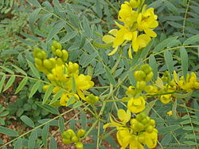
FIG: Senna alexandrina, containing anthraquinone glycosides
Glycosides are plant-derived compounds with therapeutic properties, classified into various types based on their effects:
- Anthraquinone Glycosides – Found in plants like rhubarb, cascara, and Alexandrian senna, these compounds act as natural laxatives. Herbal laxatives such as senna, rhubarb, and aloe are commonly used for their purgative effects.
- Cardiac Glycosides – Extracted from plants like foxglove and lily of the valley, these powerful compounds include digoxin and digitoxin, which are used to strengthen heart contractions and act as diuretics.
Polyphenols:
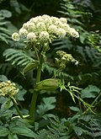
FIG: Angelica, containing phytoestrogens
Polyphenols are plant compounds with antioxidant and protective properties, playing roles in defense against diseases and predators. They include:
- Phytoestrogens – Compounds that mimic hormones and have been traditionally used to manage gynecological issues like fertility, menstruation, and menopause. Sources include Pueraria mirifica, kudzu, angelica, fennel, and anise.
- Tannins – Astringent compounds that protect plants and have been used in traditional medicine for their anti-inflammatory and antimicrobial properties.
Many polyphenolic extracts, such as those from grape seeds, olive leaves, and pine bark, are marketed as supplements and cosmetics, though their medicinal efficacy often lacks scientific validation. In Ayurveda, the rind of the pomegranate, rich in polyphenols like punicalagins, is used for its purported therapeutic effects, despite limited scientific evidence.
Preparation:
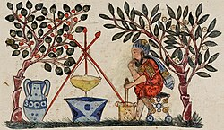
FIG: A Medieval physician preparing an extract from a medicinal plant
Medicinal plants are often tough and fibrous, requiring specific preparation techniques to extract their active compounds effectively. Common methods include:
- Decoction: Plant material is crushed and boiled in water, producing a liquid extract that can be ingested or applied topically.
- Powdering: The plant is dried and ground into a fine powder, which can be used directly or compressed into tablets.
- Alcohol Extraction: Plant material is soaked in wine or distilled spirits, forming a tincture with concentrated plant compounds.
- Poultices: Medicinal plants are boiled, wrapped in cloth, and applied externally to the affected area.
In modern medicine, once a plant’s therapeutic compound is identified, it can be synthesized or extracted in pure form, allowing for more consistent dosing and efficacy.
Conclusion:
Medicinal plants have played a vital role in traditional medicine systems throughout history, providing natural remedies for various ailments. With a rich history dating back to ancient civilizations, they remain significant in modern pharmacology due to their bioactive phytochemicals like alkaloids, glycosides, and polyphenols. The preparation methods, including decoction, powdering, and tinctures, ensure effective extraction and utilization of these compounds. As scientific research continues to validate their therapeutic potential, medicinal plants not only connect us to our cultural heritage but also present promising avenues for future drug development and sustainable healthcare.

YOGA

Introduction:
Yoga is an ancient practice originating from India, encompassing physical postures, breathing techniques, meditation, and ethical principles aimed at promoting physical, mental, and spiritual well-being. Rooted in ancient texts like the Vedas and Upanishads, yoga has evolved into various forms, ranging from Hatha Yoga, which focuses on physical postures (asanas), to Raja Yoga, which emphasizes meditation and self-discipline. Today, yoga is widely practiced worldwide for its benefits in stress reduction, flexibility, cardiovascular health, and mental clarity. It is also considered a complementary therapy in traditional and integrative medicine, helping to foster holistic health by uniting the mind, body, and spirit.
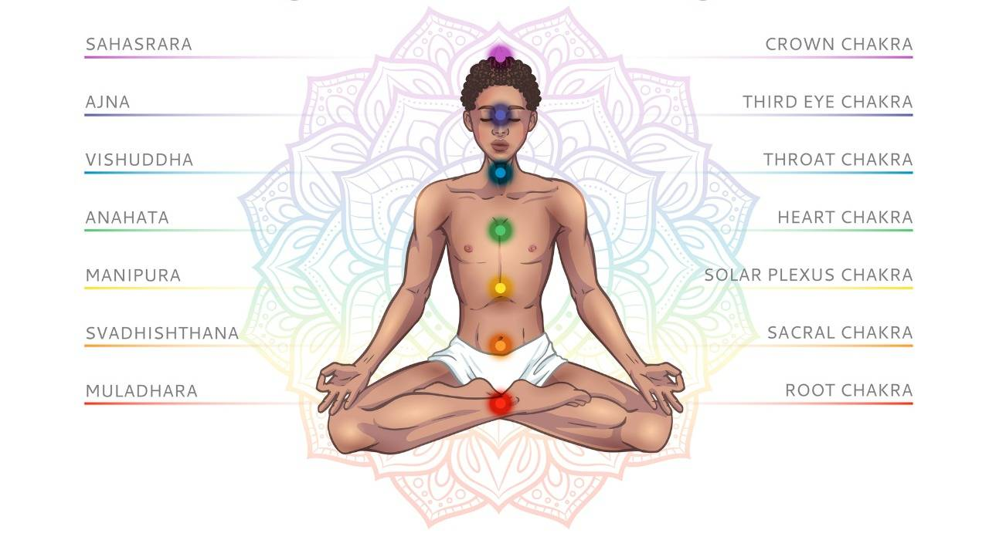
History:
Yoga, derived from the Sanskrit word "yuj," meaning "union" or "to join," first appears in the Rig Veda, one of the oldest collections of sacred texts, and dates back over 5,000 years to northern India. It is rooted in the spiritual practices of the ancient Indian sages who sought a connection between the body, mind, and spirit. The practice evolved over millennia and became a central component of Indian philosophy and spirituality.
In the late 19th century, Indian monks began to introduce yoga to the West, sparking interest among Western audiences. The teachings gained widespread popularity by the 1970s, particularly as a method for improving physical health, mental clarity, and stress management. Today, yoga is practiced globally, blending its traditional roots with modern adaptations to suit a diverse range of lifestyles and needs.
Philosophy:
The overall philosophy of yoga is about connecting the mind, body, and spirit. There are six branches of yoga. Each branch represents a different focus and set of characteristics.
The six branches are:
- Hatha yoga: This is the physical and mental branch that aims to prime the body and mind.
- Raja yoga: This branch involves meditation and strict adherence to a series of disciplinary steps known as the eight limbs of yoga.
- Karma yoga: This is a path of service that aims to create a future free from negativity and selfishness.
- Bhakti yoga: This aims to establish the path of devotion, a positive way to channel emotions and cultivate acceptance and tolerance.
- Jnana yoga: This branch of yoga is about wisdom, the path of the scholar, and developing the intellect through study.
- Tantra yoga: This is the pathway of ritual, ceremony, or consummation of a relationship.
Chakras:
The word “chakra” means “spinning wheel.” Yoga maintains that chakras are center points of energy, thoughts, feelings, and the physical body. According to yogic teachers, chakras determine how people experience reality through emotional reactions, desires or aversions, levels of confidence or fear, and even physical symptoms and effects.
When energy becomes blocked in a chakra, it triggers physical, mental, or emotional imbalances that manifest in symptoms such as anxiety, lethargy, or poor digestion. Asanas are the many physical poses in Hatha yoga. People who practice yoga use asanas to free energy and stimulate an imbalanced chakra.
There are seven major chakras:
- Sahasrara: The crown chakra, which is at the crown of the head, symbolizes spiritual connection.
- Ajna: Located between the eyebrows, the third eye chakra has to do with intuition.
- Vishuddha: The throat chakra corresponds to immunity and verbal communication.
- Anahata: The heart chakra, which is in the center of the chest, influences professional and personal relationships. Any imbalances in this chakra will affect oxygen, hormones, tissue, and organ control.
- Manipura: The solar plexus chakra is in the stomach area. It corresponds to self-confidence, wisdom, and self-discipline.
- Svadhishthana: The sacral chakra, which is beneath the belly button, connects pleasure, well-being, and vitality.
- Muladhara: The root chakra, which is at the base of the spine, connects the mind and body to the earth to keep a person grounded. It controls the sciatic nerves and the parasympathetic nervous system.
Types:
Ashtanga yoga: This type of yoga practice uses ancient yoga teachings. However, it became popular during the 1970s. Ashtanga applies the same poses and sequences that rapidly link every movement to breath.
Bikram yoga: People practice Bikram yoga, also known as hot yoga, in artificially heated rooms at a temperature of nearly 105ºF and 40% humidity. It consists of 26 poses and a sequence of two breathing exercises.
Hatha yoga: This is a generic term for any type of yoga that teaches physical poses. Hatha classes usually serve as a gentle introduction to the basic poses of yoga.
Iyengar yoga: This type of yoga practice focuses on finding the correct alignment in each pose with the help of a range of props, such as blocks, blankets, straps, chairs, and bolsters.
Kripalu yoga: This type teaches practitioners to know, accept, and learn from the body. A student of Kripalu yoga learns to find their own level of practice by looking inward. The classes usually begin with breathing exercises and gentle stretches, followed by a series of individual poses and final relaxation.

Kundalini yoga: Kundalini yoga is a system of meditation that aims to release pent-up energy. A Kundalini yoga class typically begins with chanting and ends with singing. In between, it features asana, pranayama, and meditation that aim to create a specific outcome.

Power yoga: In the late 1980s, practitioners developed this active and athletic type of yoga based on the traditional Ashtanga system.

Sivananda: This system uses a five point philosophy as its foundation. This philosophy maintains that proper breathing, relaxation, diet, exercise, and positive thinking work together to create a healthy yogic lifestyle. People practicing Sivananda use 12 basic asanas, which they precede with Sun Salutations and follow with Savasana.

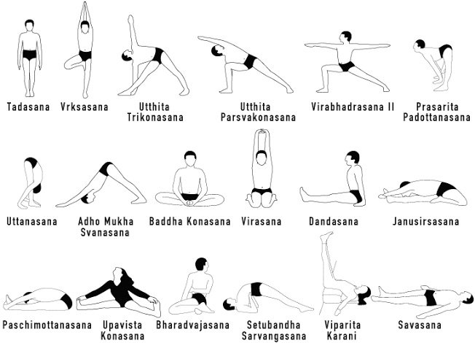

Benefits of yoga:
Yoga has many physical and mental benefits
- Building muscle strength
- Enhancing flexibility
- Promoting better breathing
- Supporting heart health
- Helping with treatment for addiction
- Reducing stress, anxiety, depression, and chronic pain
- Improving sleep
- Enhancing overall well-being and quality of life
Conclusion:
Yoga is a holistic discipline that fosters harmony between the body, mind, and spirit. Originating in ancient India, it combines physical postures, breathing techniques, and meditation. Today, it is widely practiced worldwide for its health and stress-relief benefits. Yoga promotes self-awareness and inner balance, making it a valuable tool for overall well-being.

